* In the last blog, we have seen the general criteria and examples of Most Powerful Test and Uniformly Most Powerful Test.

Let us study the concept of Uniformly Most Powerful Test little deeply and other Tests.

* ***Non Existence of Uniformly Most Powerful Test*** :- In past blog, we have seen that, “For a two-tailed test, *UMP Test* does not exist except U[0,Ɵ].”

Let us understand it well.

Consider an example of testing, H0 : Ɵ = Ɵ0 vs H1 : Ɵ = Ɵ1, if random sample is drawn from N(Ɵ, σ2), σ2 is known, we have the following cases.

Case (i) : If H0 : Ɵ = Ɵ0 vs H1 : Ɵ = Ɵ1 (> Ɵ0)

The BCR is

W1 = { : > K1} _____ (A)

Case (ii) : If H0 : Ɵ = Ɵ0 vs H1 : Ɵ = Ɵ1 (< Ɵ0)

The BCR is

W2 = { : ≤ K2} _____ (B)

If we take n = 2, the BCR for testing H0 : Ɵ = Ɵ0 vs H1 : Ɵ = Ɵ1 (> Ɵ0) is given by,

From eqn (A)

W1 = {(X1, X2) : (X1 + X2) ≥ K1}

i.e. W1 = {(X1, X2) : (X1 + X2) ≥ + Ɵ0}

W1 = {(X1, X2) : (X1 + X2) ≥ C1} _____ (1)

Similarly, the BCR for testing H0 : Ɵ = Ɵ0 vs H1 : Ɵ = Ɵ1 (> Ɵ0) is given by,

From eqn (B)

W2 = {(X1, X2) : (X1 + X2) ≤ C2} _____ (2)

The BCR for testing H0 : Ɵ = Ɵ0 vs H1 : Ɵ ≠ Ɵ0

W3 = {(X1, X2) : (X1 + X2) ≥ C1 (X1 + X2) ≤ C2} _____ (3)

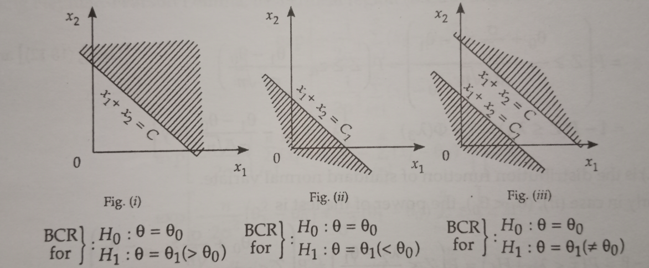

eqn (A) defines an UMP test for testing

H0 : Ɵ = Ɵ0 vs H1 : Ɵ = Ɵ1 (> Ɵ0)

whereas, eqn (B) defines an UMP test for testing

H0 : Ɵ = Ɵ0 vs H1 : Ɵ = Ɵ1 (< Ɵ0)

However, no UMP test exist for testing

H0 : Ɵ = Ɵ0 vs H1 : Ɵ ≠ Ɵ0

**Exceptional Case** :

Let 1, 2, ….. , n be a random sample of size n from U(0, Ɵ). The test for testing

H0 : Ɵ = Ɵ0 vs H1 : Ɵ ≠ Ɵ0

This is an unique example where the UMP test exists for two-sided alternative hypotheses.

* ***Likelihood Ratio Test*** :- NP lemma based on the magnitude of the ratio of two probability density functions provided best test for testing simple hypothesis against simple alternative hypothesis. The best test in any given situation depends on the nature of the population distribution in the form of the alternative hypothesis being considered. A general method of test construction called the *likelihood ratio (L.R.)* *Test* introduced by name Neyman and Pearson for testing a hypothesis, simple or composite, against simple or composite alternative hypothesis. This test related to the maximum likelihood estimates.

Let 1, 2, ….. , n be a random sample from density f($x;Ɵ$) where Ɵ = (1, 2, ….. , m). Suppose one is interested in testing the hypothesis H0 : Ɵ = Ɵ0 where Ɵ0 ϵ Ɵ0. In likelihood ratio test we consider the likelihood functions under H0 and under the entire parametric space. The Ratio,

λ($x$) = $\frac{L(x/Ɵ_{0})}{L(x/Ɵ)}$

Is called the *likelihood ratio*. The value of λ($x$) lies in the interval (0, 1).

The critical region for the test statistic is λ($x$) ≤ k, where k is determined from the distribution g() of λ to provide a test of size α, i.e.,

$\int_{0}^{k}{g_{H_{0}}()d}$ = α

* ***Properties of Likelihood Ratio Test*** :- Likelihood Ratio (LR) test principle is an intuitive one. If we are testing a simple hypothesis H0 against a simple alternative hypothesis H1 then the likelihood restaurant principal leads to the same test has given by the Neyman-Pearson Lemma. Suggests that LR test has some desirable properties, specially large simple properties.

In Likelihood Ratio (LR) test, the probability of type I error is controlled by suitably choosing the cut-off point λ0. *LR* test is generally *UMP* if a *UMP* test at all exists, We state below, the two asymptotic properties of *LR* tests.

1. Under certain conditions, -2 $\log_{e}$ λ has an asymptotic chi-square distribution.
2. Under certain assumptions, *L.R.* test is consistent.